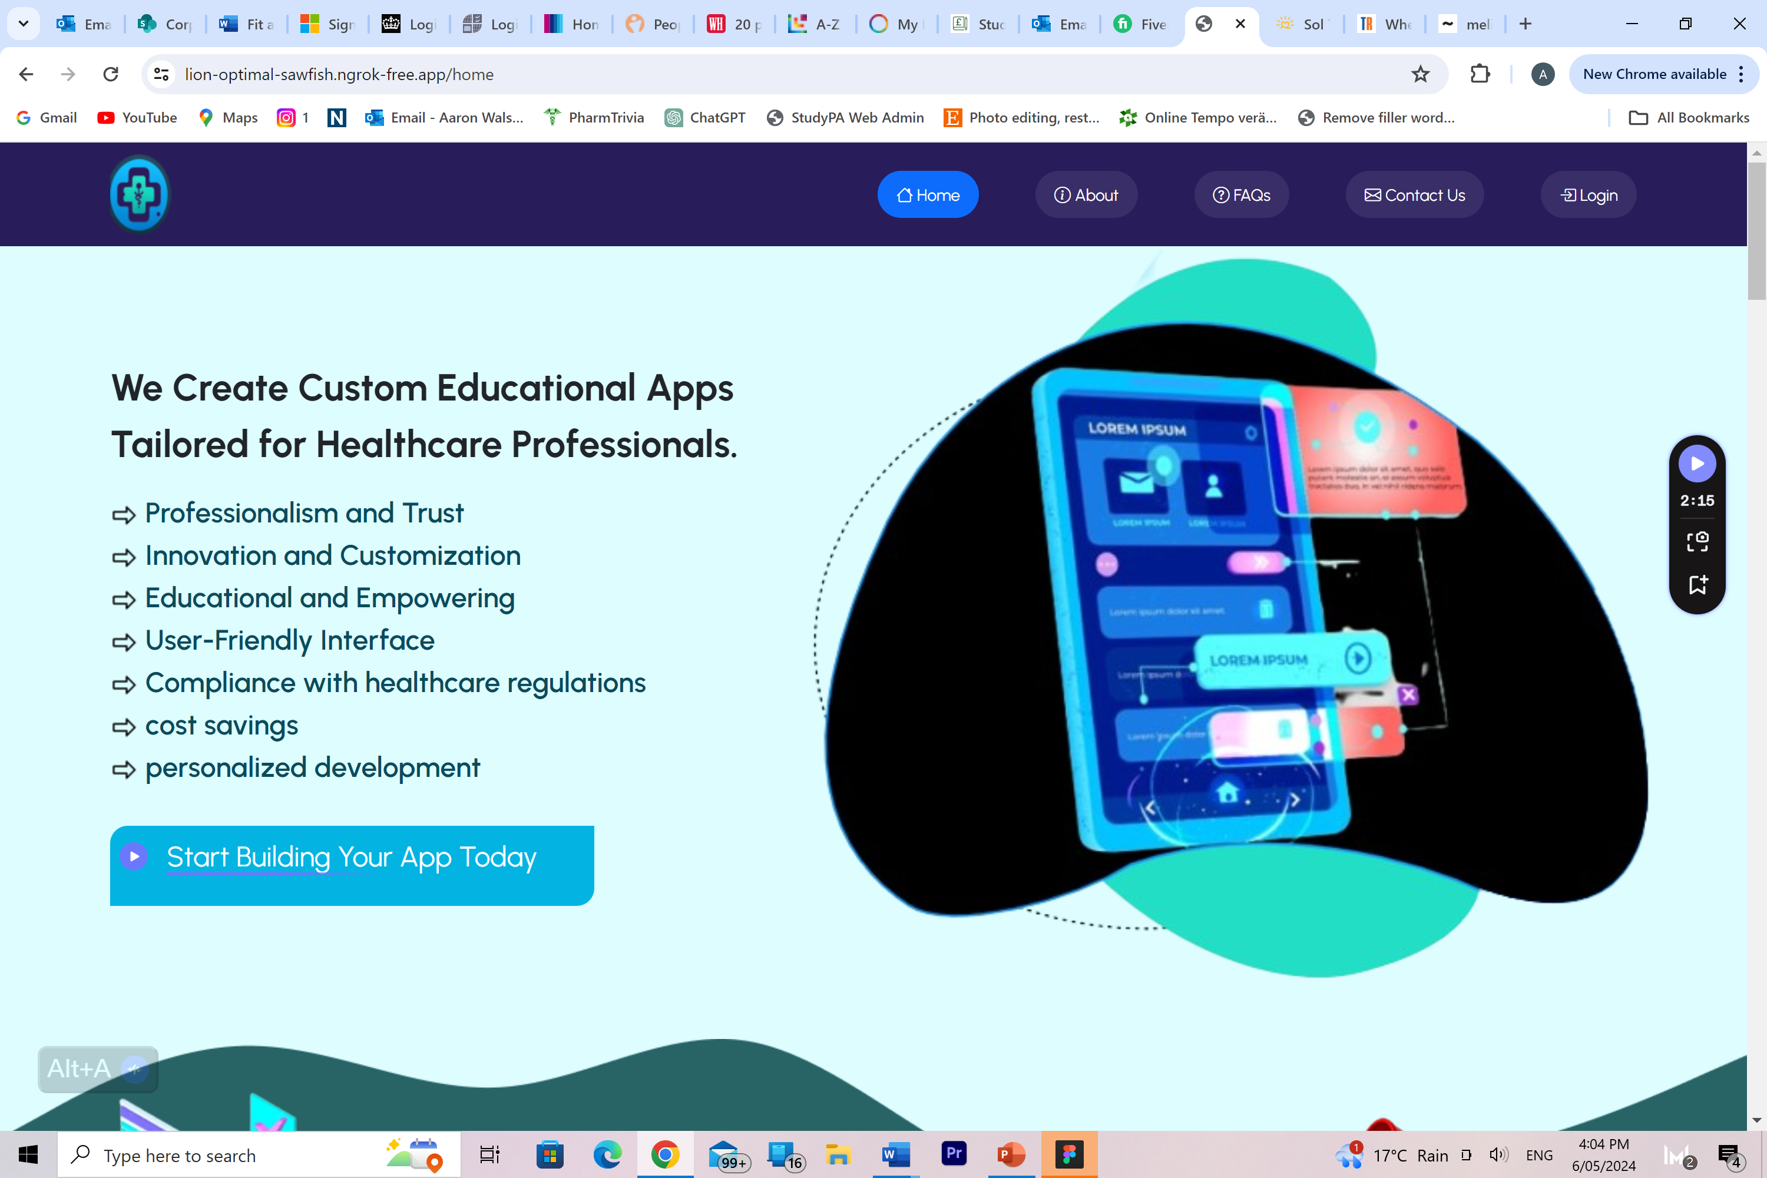

Start you app today button doesn’t work

Image on right super blurry

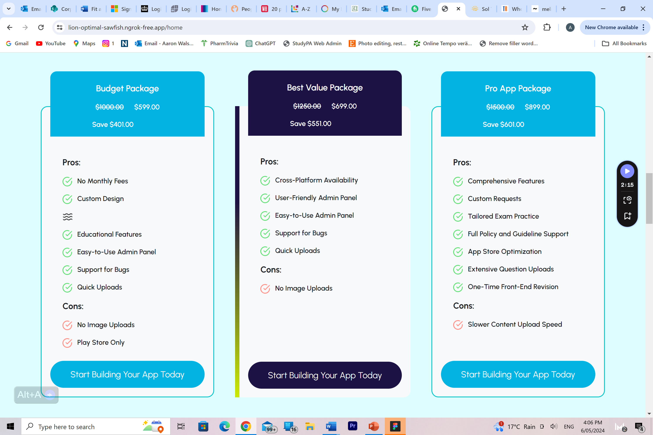

Again buttons not functional

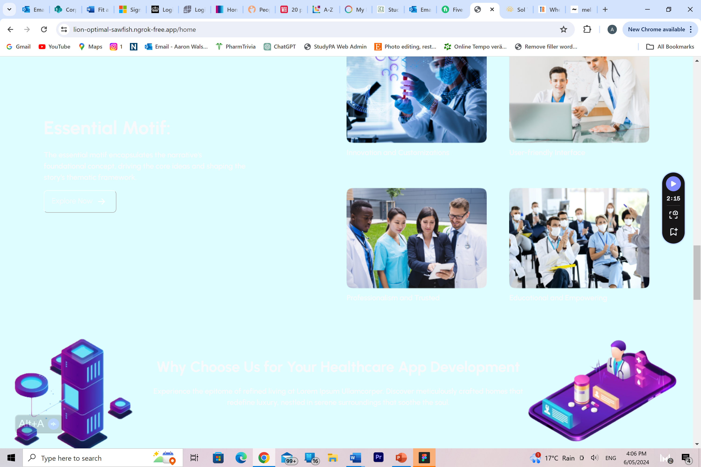

Just look at the writing here, you cant see it at all

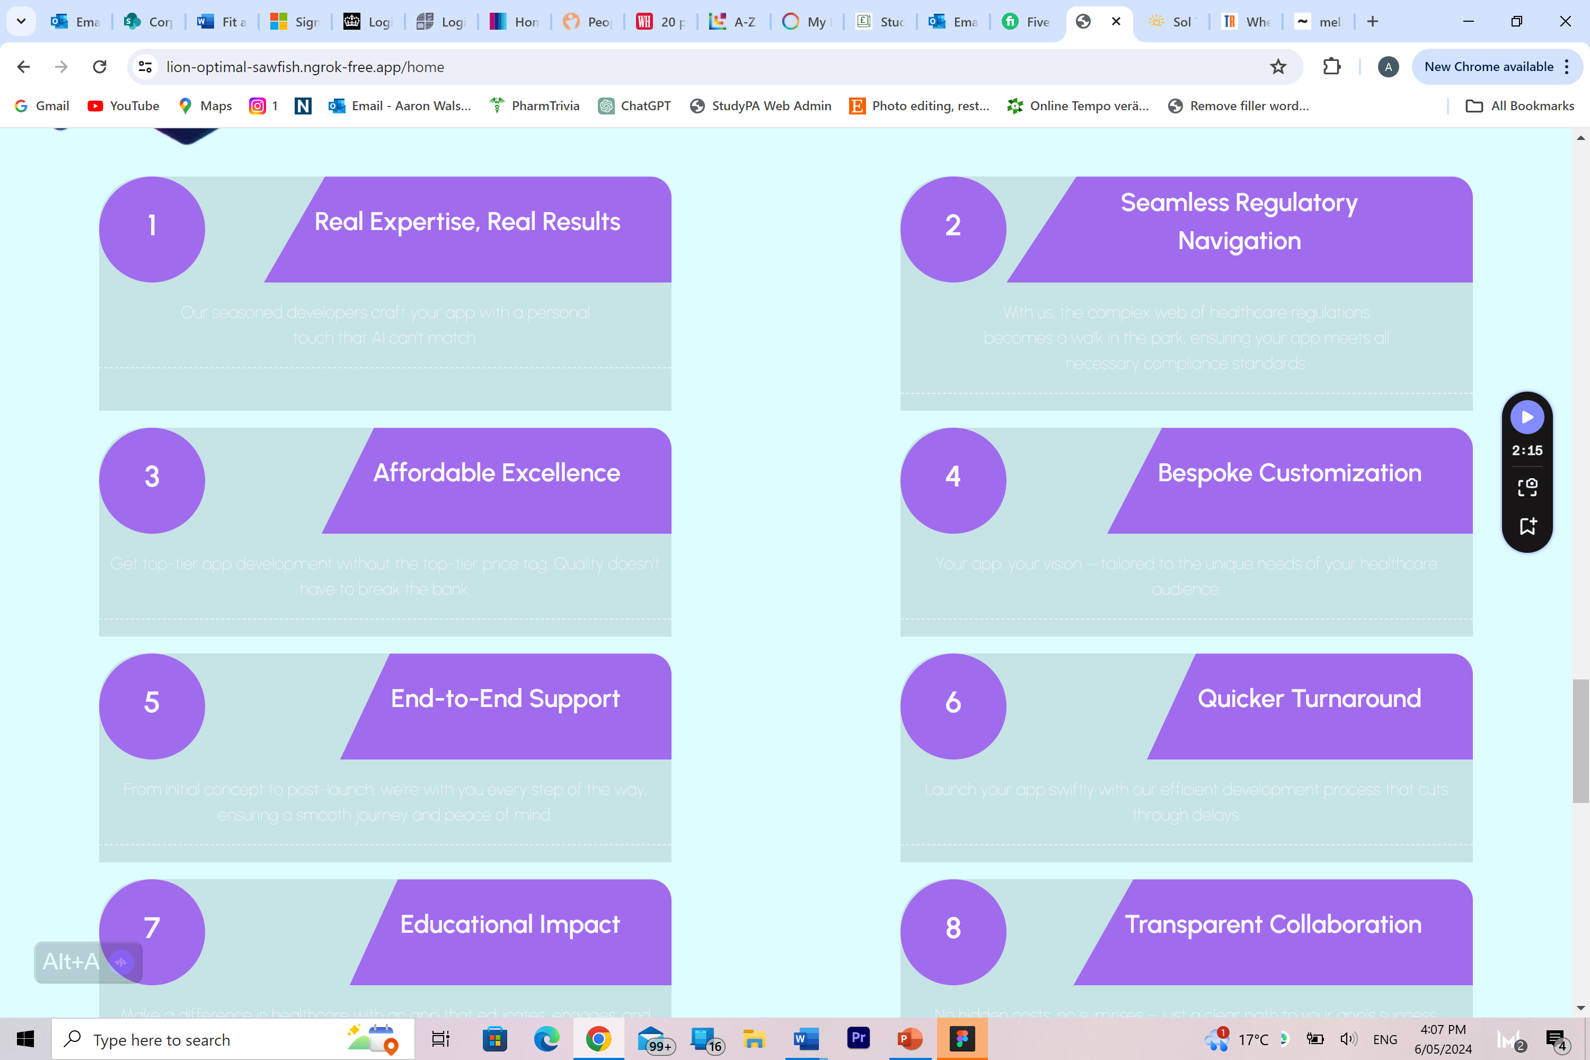

Again, this is clearly wrong you cannot see the writing? I wouldn’t expect this to be missed

Also these as supposed to be animated showing up in numerical order

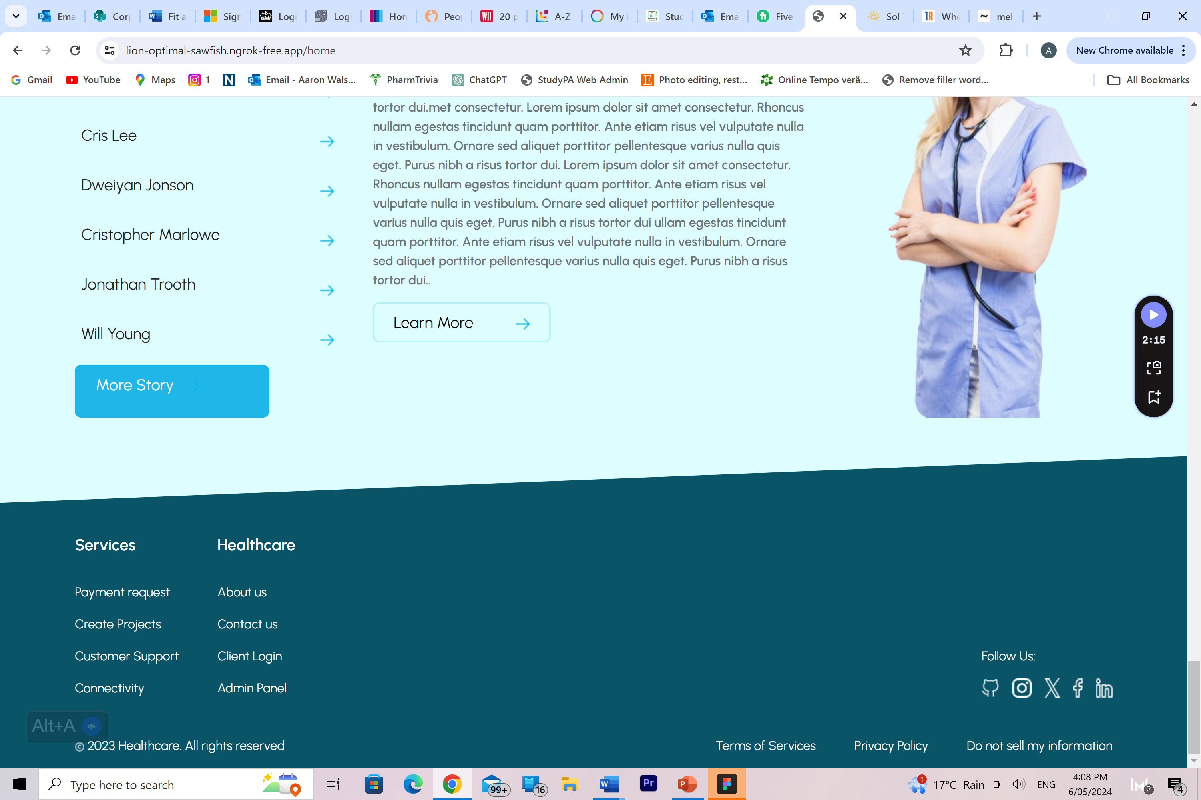

“More stories” will need to remove some of these as the site needs to look complete

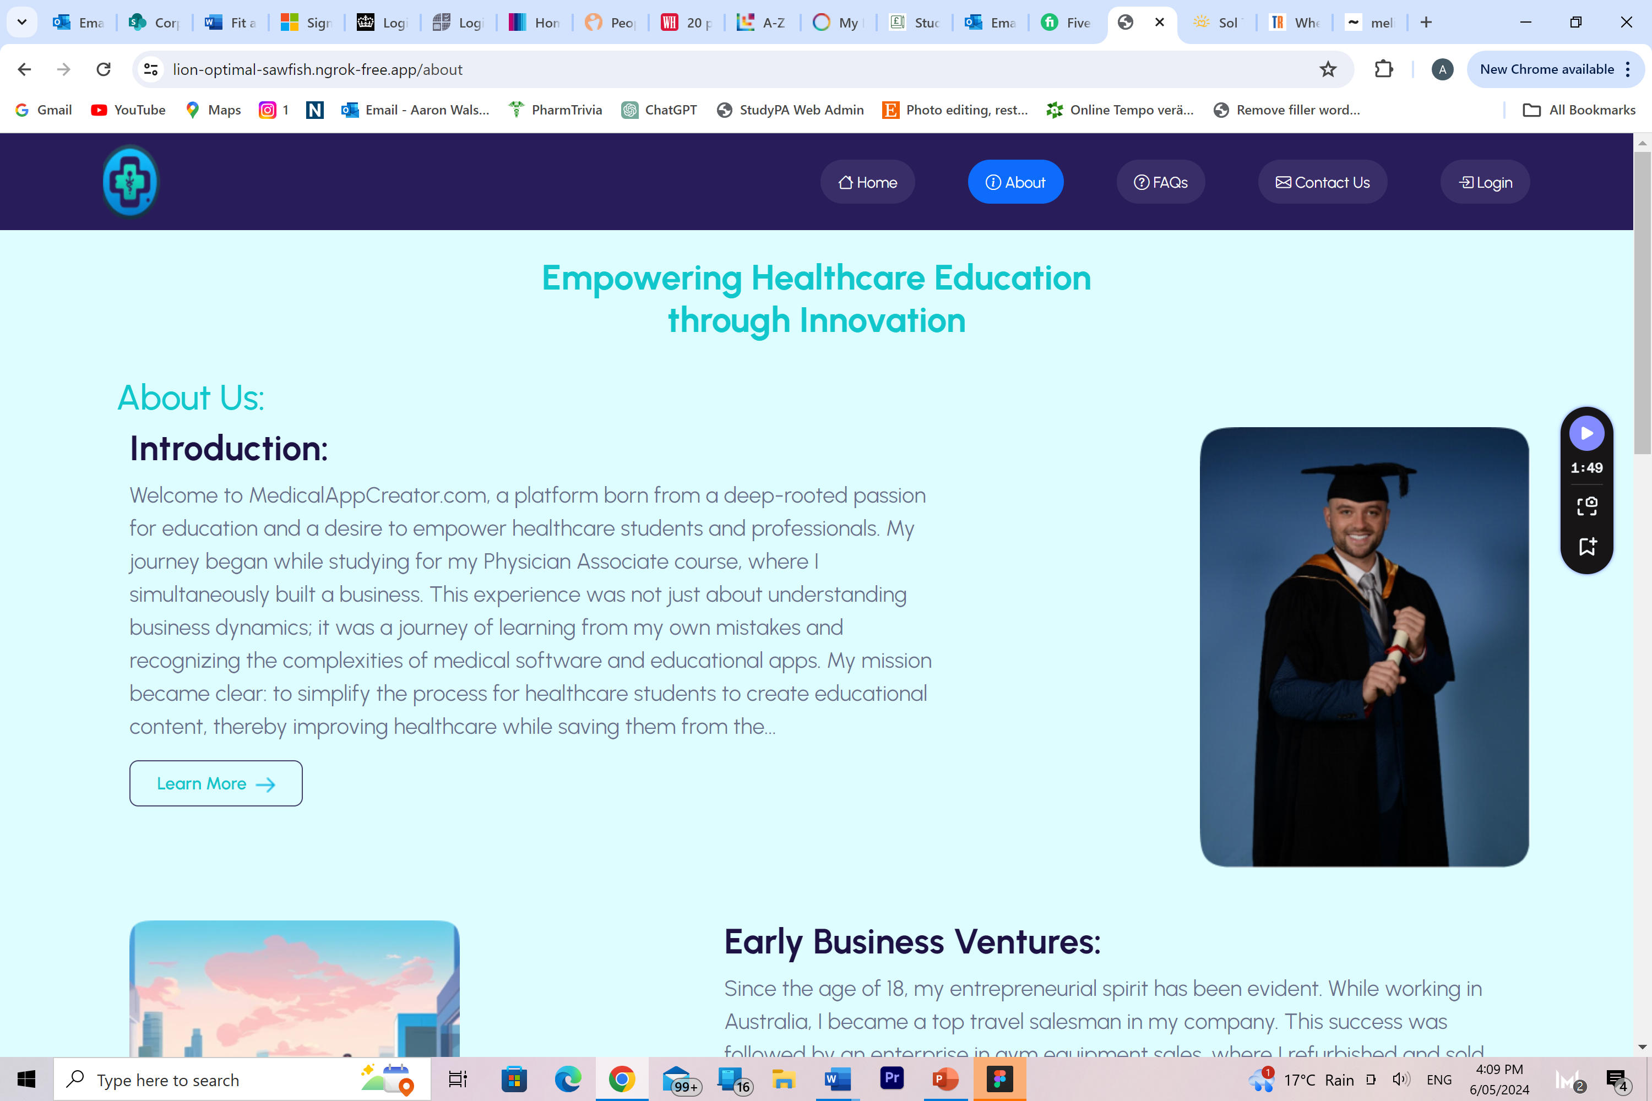

Learn more buttons not working, I provided all the content for these.

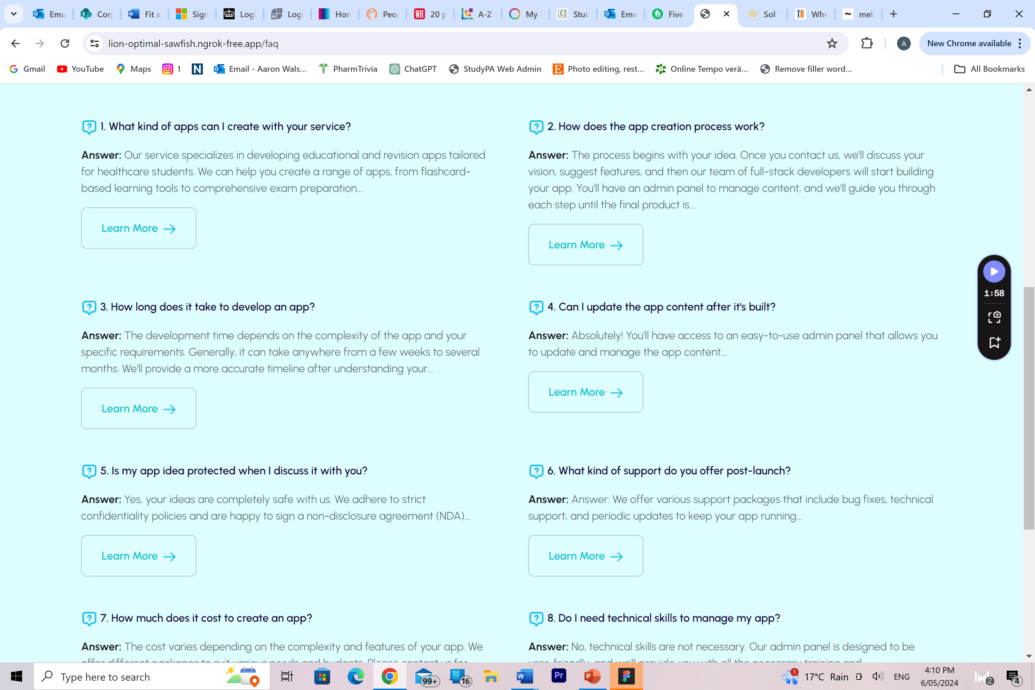

Learn more not functional

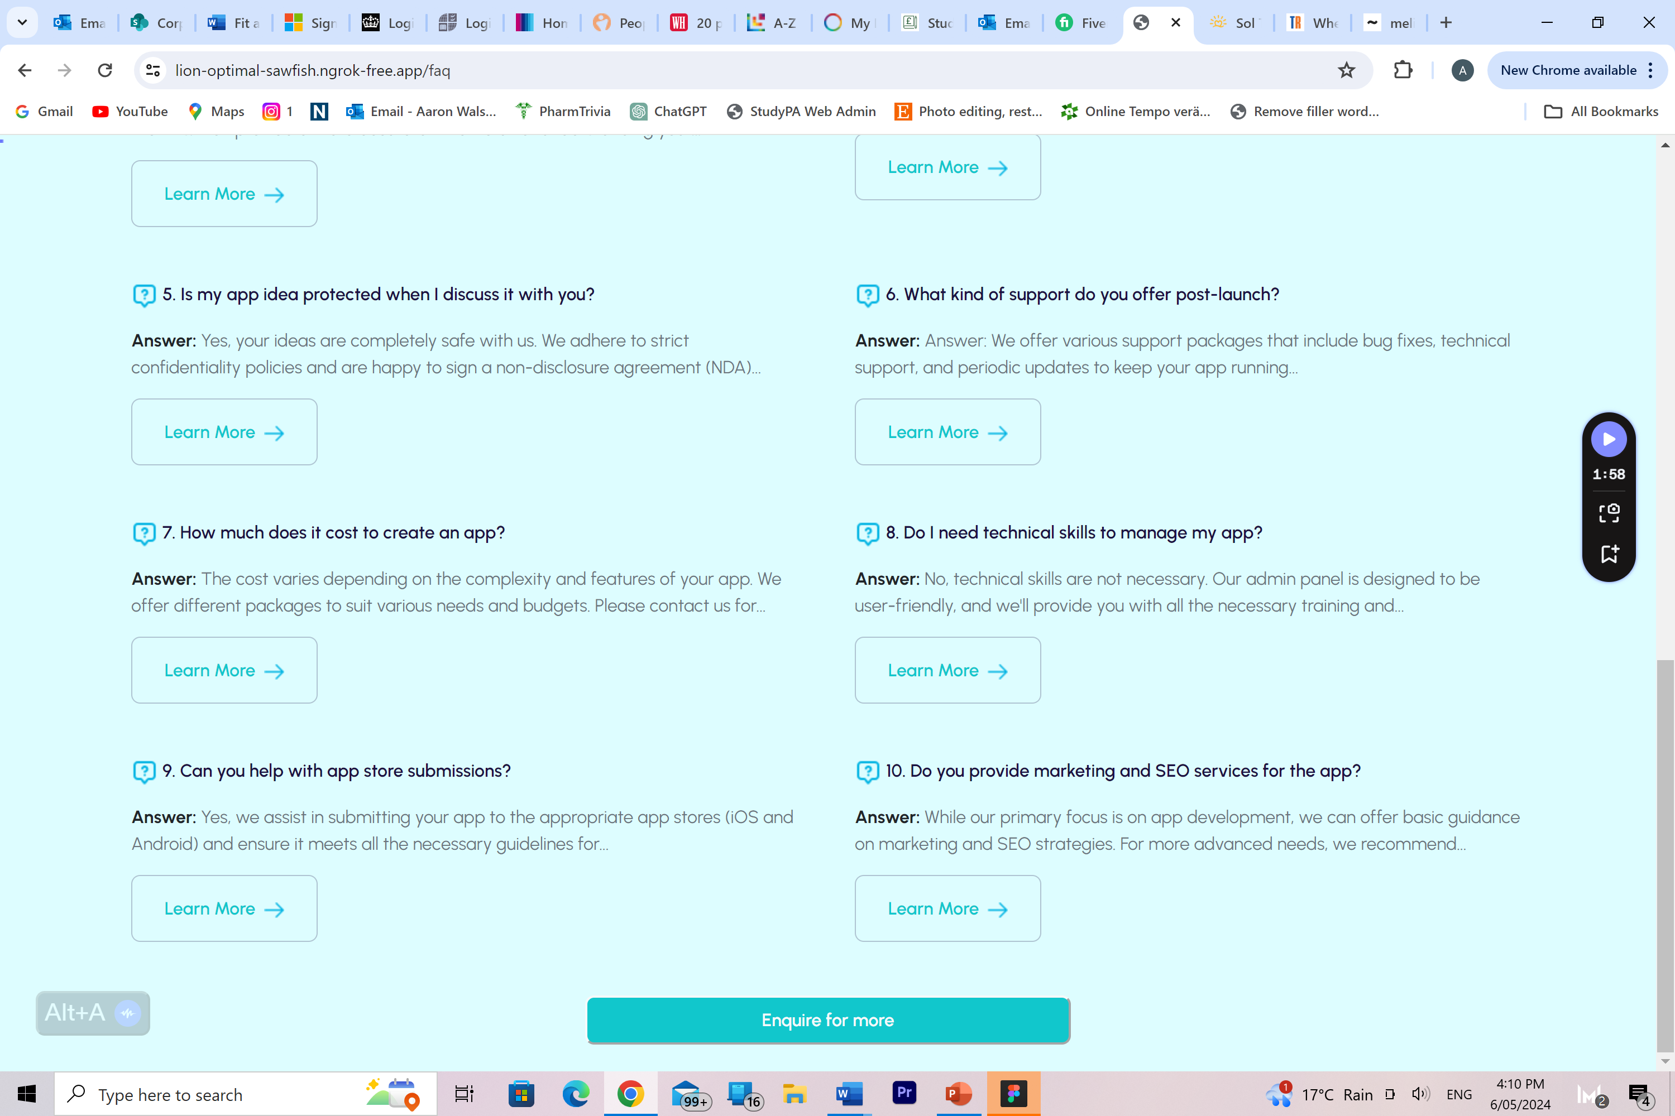

Enquire button not functional

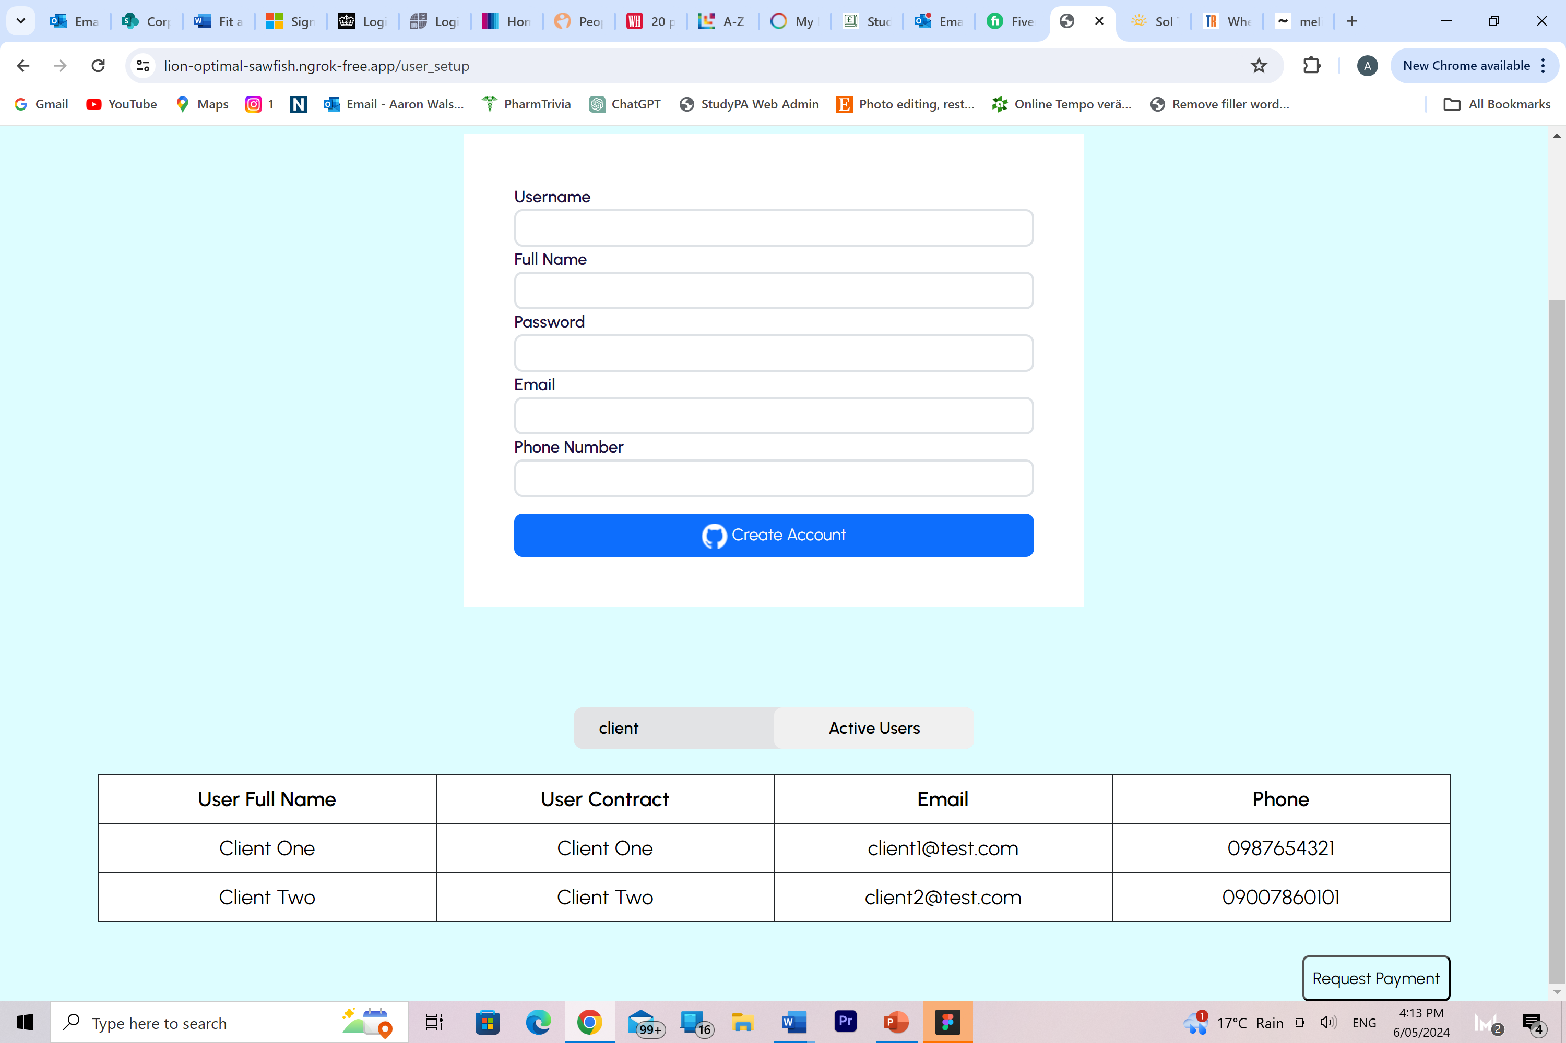

Does this search bar work for searching users?

Also request payment button is not working, this is so I can inform the users on their account, and how much

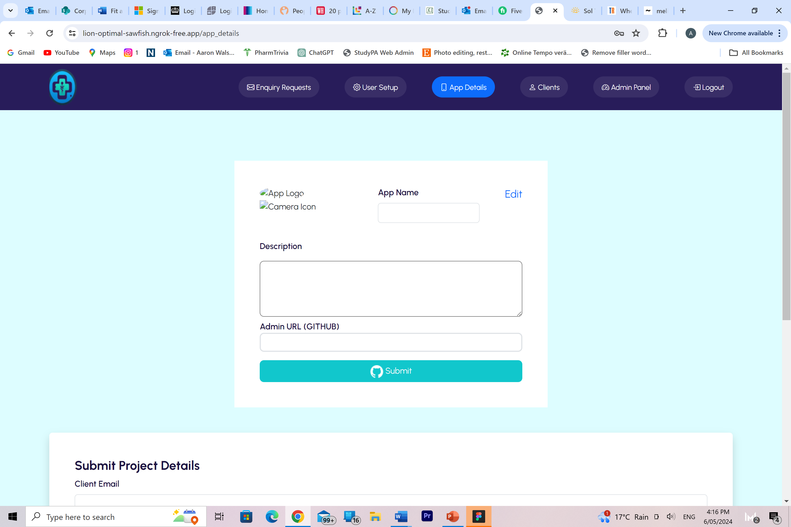

This will have to link to the user setup we made, so will need the ability to search the users in here, then select them and fill in these details for them so they can see it in their client login

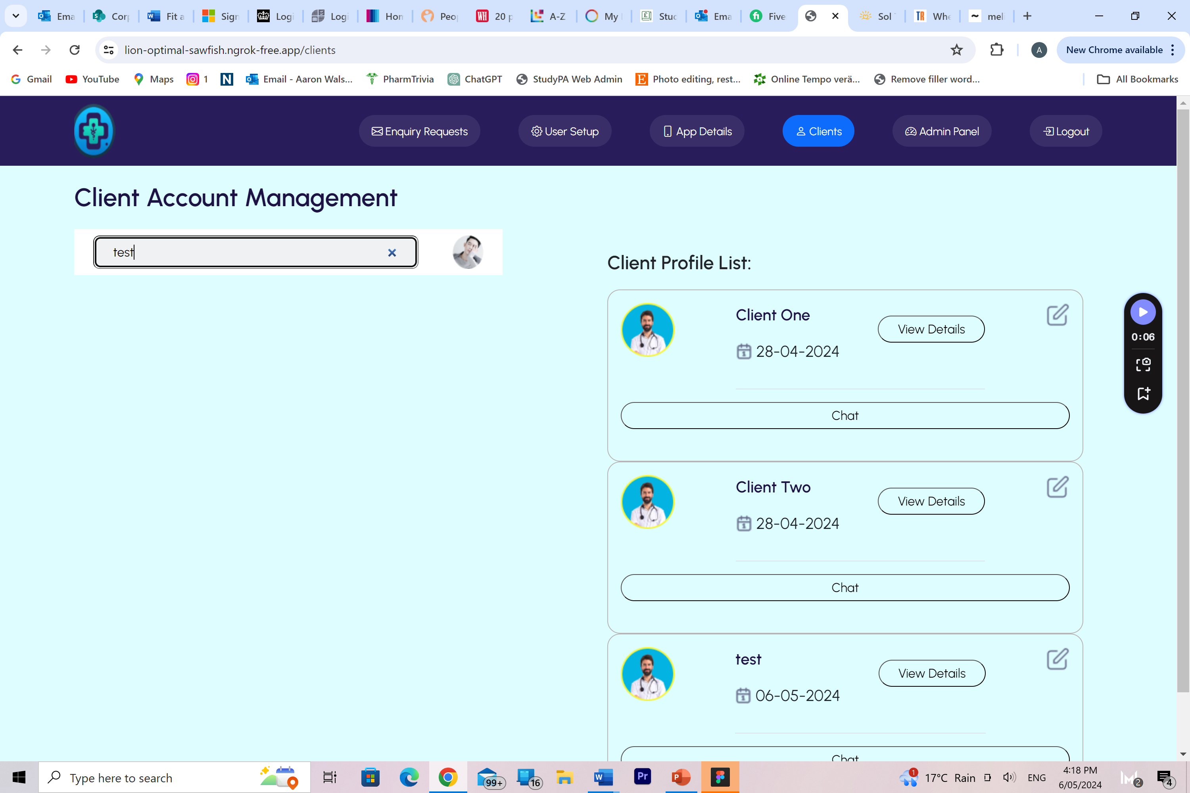

Again does this search panel work?

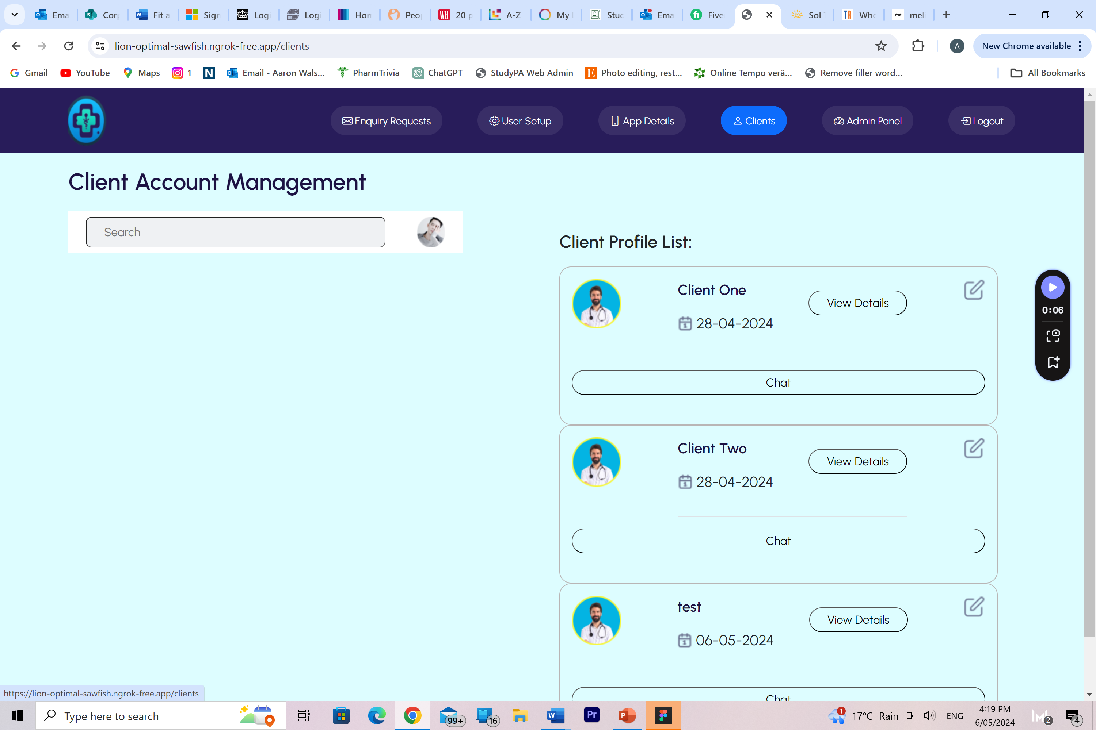

Also does this edit button next to profiles doesn’t work?

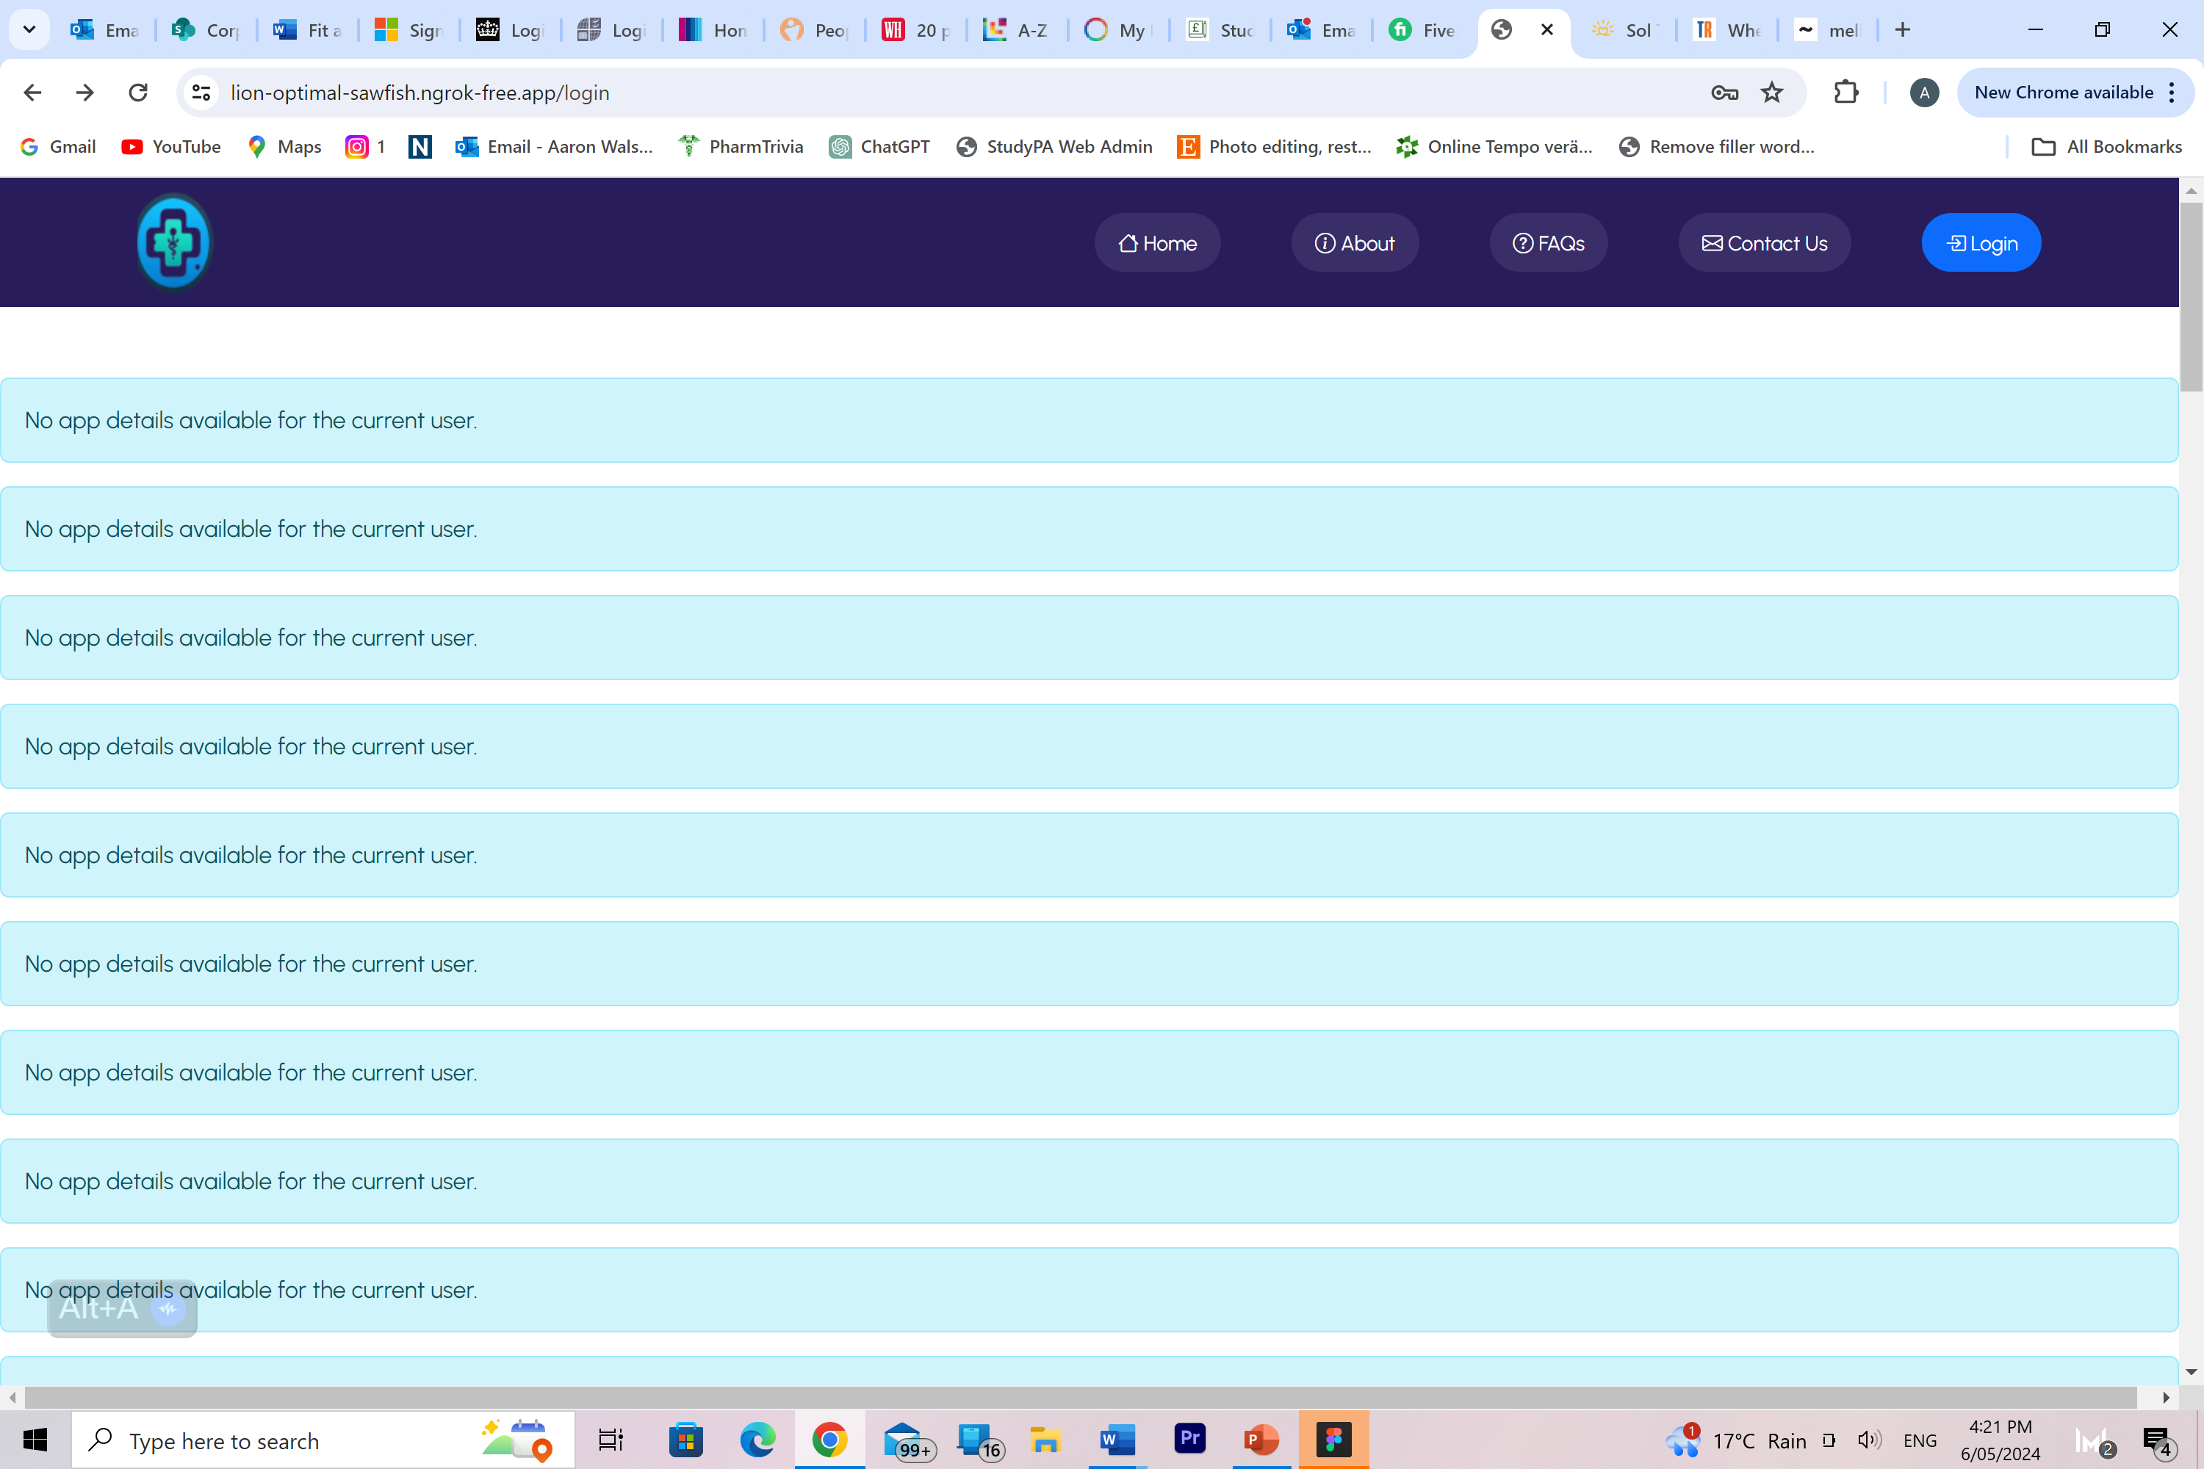

Tried logging in as one of the clients I made up and loaded for ages then showed up with this?